Tennessee Conservation Grant

Final Report

I. Summary Information

Grant Information
Project Name: | Northeast Tennessee Community Science

Chapter Name: | 492 - Overmountain Chapter

Project Start Date: | 11/1/2020 | Project End Date: | 6/3/2022

Grant Amount: | $4114

Are there any unexpended funds remaining? | No | Amount: | $0

Participating Partners:
TU Volunteer Hours Completed:

Contact Information
Name: | Ryan Turgeon | Email Address: | ryanturgeon76@yahoo.com

Phone: | (570) 351-5975 | Title: | Board Member

Report Prepared by: | Ryan Turgeon | Date Submitted | 7/5/2022

Phone: | (570) 351-5975

Email: | ryanturgeon76@yahoo.com

II. Final Project Results

Executive Summary
- General Results: How did your project benefit trout in Tennessee? Describe the general results of the project, including where the project results were achieved as expected, where they were not, and the reasons for both. In addition, please describe any unexpected results and their significance. How will the results you accomplished in the short term affect the long-term goals you identified in your proposal?

- Challenges: Discuss how you addressed both anticipated and unanticipated challenges during the project.

- Lessons Learned: What lessons have you learned during this project that will help your organization and other organizations that may be involved in similar work?

- Sustainability Plans: Describe how you will sustain the results from this project. Is additional funding needed in future years, is it self sustaining, etc?

- Project Visibility: Discuss how you communicated your project to the media or community and the type of outlets (e-mail, social media placements, internet placements, newspaper, radio spots, television spots) you used.

III. Final Budget Report

Budget Summary
Please fill in the proposed vs. actual project budget. Was it necessary for you to make any significant changes to the proposed project budget? If so, please explain.
Item | Proposed Cost | Actual Cost | Remaining
Lifting equipment | $2,184.00 | $2,287.00 | ($101.00)
Kick Nets and Sieves | $430.00 | $360.08 | $69.92
Fish tanks | $1,000.00 | $950.66 | $1,346.34
Shirts for participants | $500.00 | $650.00 | ($150.00)
Total | $4,114.00 | $4,247.74 | ($133.74)

- Significant changes

IV. Pictures
Insert any pictures that show the work that was accomplished during the project.
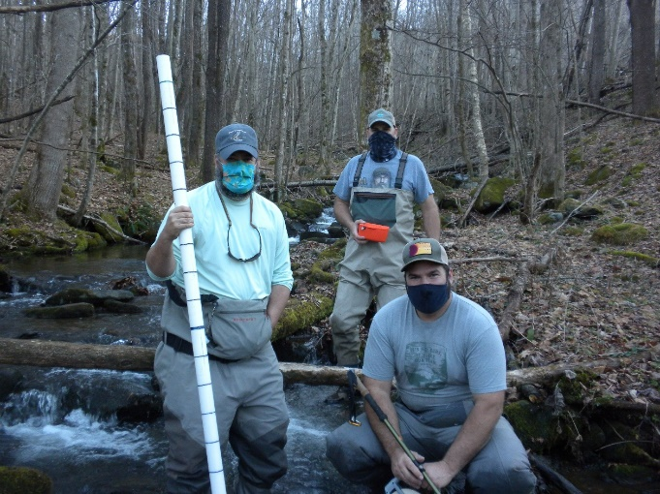 | 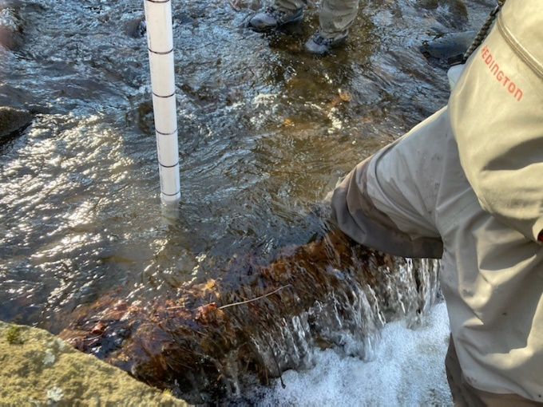
Volunteers during the woody debris survey training at Left Prong Hampton Creek in Carter County | Tool used to measure the size of the woody debris
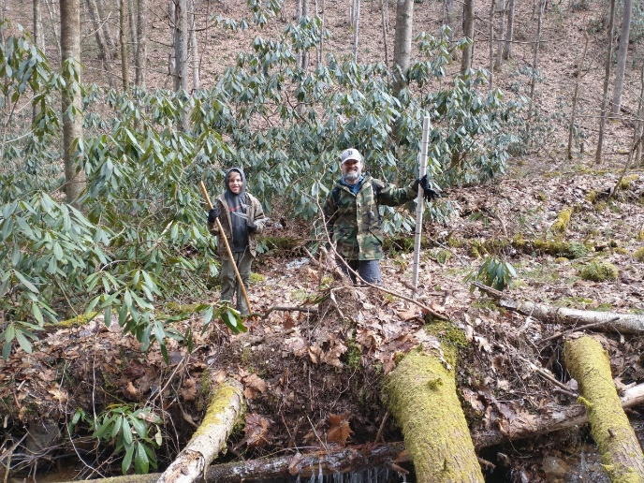 | 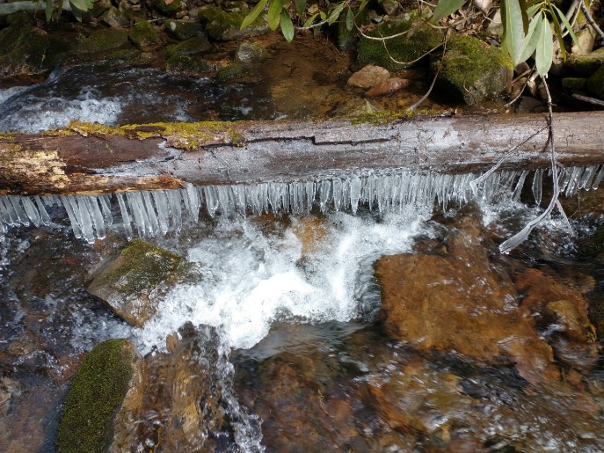
Volunteers conducting a stream survey on Chalk Branch in Johnson County | Ice on Chalk Branch during stream survey

